Static Equilibrium Lab

The purpose of this lab it to measure the mass of an object without using an electronic balance.

Materials:
T-bar
String- about 1m long with a loop tied on each end
2 Newton meters
A hanging mass (500g)
Protractor
Tape
Electronic balance

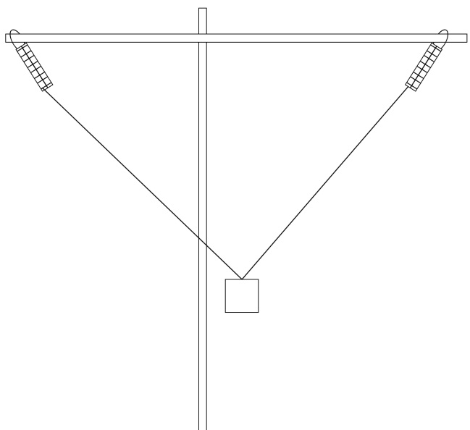
Procedure:
Assemble the apparatus as shown:
Use tape to prevent the Newton meters
from sliding to the middle.
Hang the mass in the approximate middle of the string.
Adjust the position of the mass until both Newton meters
have the same value.
Measure and record the angle between the top bar and
the string (or Newton meter).
Record the readings on the Newton meters and the angles.
Be sure to indicate left and right side for each measurement.
Measure the mass of the hanging weight on an electronic balance.

Data and Calculations:
Use 9.81m/s² as the acceleration of gravity.
Calculate the forces on each of the Newton meters in the
vertical and horizontal directions.
Using those values, calculate the weight of the hanging mass and then its mass.
Calculate the percent error between the calculated mass (above) and measured mass from the
electronic balance.

Conclusions:
Include insights about:
How it was possible to measure the mass of an object without using an electronic balance?
How accurate you were.
What may have caused any inaccuracies?
What would you need to make a more accurate determination of mass?

