Name: Period:
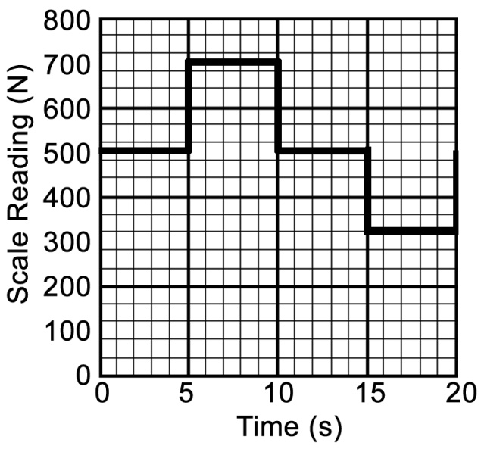
Life on an Elevator

A student whose normal weight is 500 newtons stands on a scale in an elevator and records the scale reading as a function of time. The data are shown in the graph above. At time = 0, the elevator is at displacement x = 0 with velocity v = 0. Assume that the positive directions for displacement, velocity and acceleration are upward.

a) On the diagram below, draw and label all of the forces on the student at t = 8 seconds.

b) Calculate the acceleration of the elevator for each 5-second interval.
i. indicate your results by completing the following table.
Time interval (s) | 0-5 | 5-10 | 10-15 | 15-20
a (m/s²)

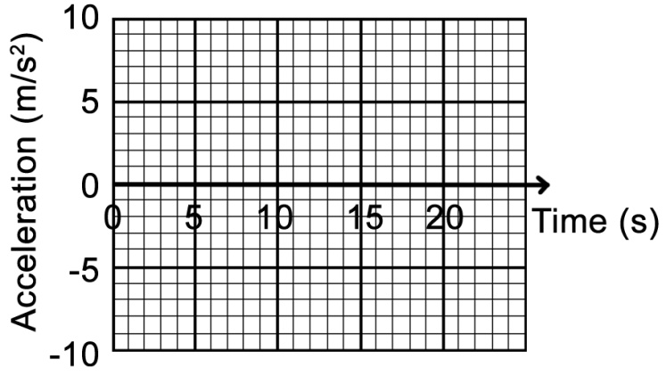
ii. Plot the acceleration as a function of time on the following graph.

c) Determine the velocity of the elevator at the end of each 5-second interval.
i. Indicate your results by completing the following table.
Time interval (s) | 0-5 | 5-10 | 10-15 | 15-20
v (m/s)

ii. Plot the velocity as a function of time on the following graph.
