Name: Period:
Tension Problems
1. Find the tension in cables A and B if the mass of the sign is 80 kg?
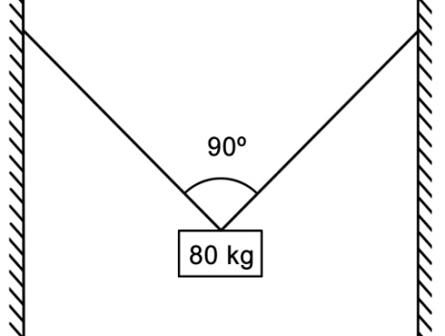

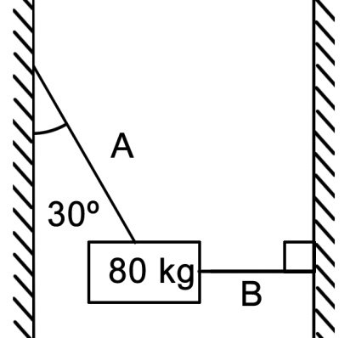
2. Find the tension in cables A and B if the mass of the sign is 80 kg?

3. What is the mass of the sign if the force in the bar is 500 N?
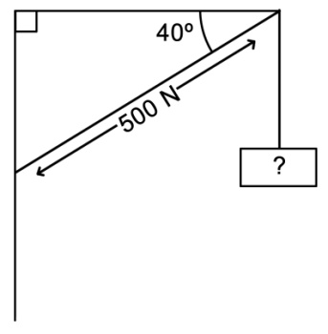

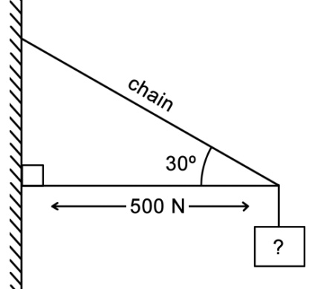
4. What is the mass of the sign if the force in the bar is 500 N?

