Name: Period:
All Motion Equations of Motion 3
1. A car moving at a speed of 8.0 meters per second enters a highway and accelerates at 3.0 meters per second². How fast will the car be moving after it has accelerated for 56 meters?

2. A child riding a bicycle at 15 meters per second decelerates at the rate of 3.0 meters per second² for 4.0 seconds. What is the child’s speed at the end of the 4.0 seconds?

3. A race car traveling at 10 meters per second accelerates at 1.5 meters per seconds² while traveling a distance of 600 meters. The final speed of the race car is approximately

4. A car accelerates uniformly from rest at 3.2 m/s². When the car has traveled a distance of 40 meters, its speed will be

5. A boat initially traveling at 10 meters per second accelerates uniformly at the rate of 5.0 meters per second² for 10 seconds. How far does the boat travel during this time?

6. A truck with an initial speed of 12 meters per second accelerates uniformly at 2.0 meters per second² for 3.0 seconds. What is the total distance traveled by the truck during this 3.0-second interval?
7. An object originally at rest is uniformly accelerated along a straight-line path to a speed of 8.0 meters per second in 2.0 seconds. What was the acceleration of the object?

8. An object originally moving at a speed of 20 meters per second accelerates uniformly for 5.0 seconds to a final speed of 50 meters per second. What is the acceleration of the object?

9. An object has a constant acceleration of 2.0 meters per second². The time required for the object to accelerate from 8.0 meters per second to 28 meters per second is

10. A jogger accelerates at a constant rate as she travels 5.0 meters along a straight track from point A to point B, as shown in the diagram below.
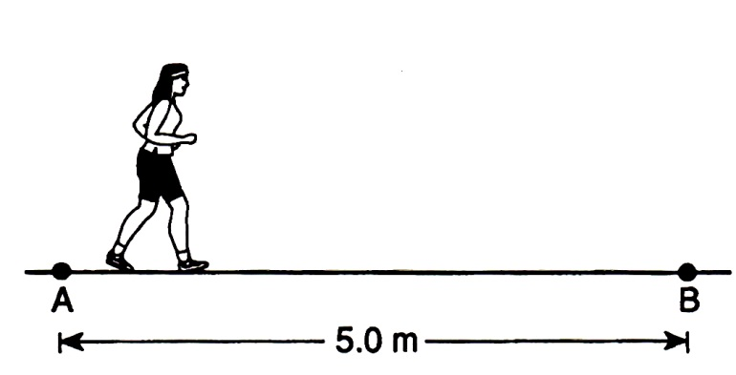

If her speed was 2.0 meters per second at point A and will be 3.0 meters per second at point B, how long will it take her to go from A to B?

