Name: Period:
Displacement vs Time Graphs 3
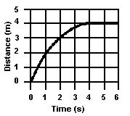
1. The graph represents the relationship between distance and time for an object. What is the instantaneous speed of the object at t = 5.0 seconds?

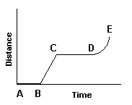
2. The graph represents the relationship between distance and time for an object in motion. During which interval is the speed of the object changing?

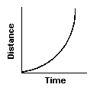
3. The diagram shows a graph of distance as a function of time for an object in straight-line motion. According to the graph, the object most likely has
- a constant momentum
- a decreasing acceleration
- a decreasing mass
- an increasing speed

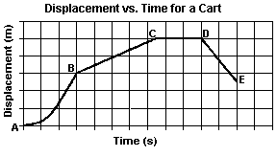
4. The displacement-time graph shows the motion of a cart along a straight line. During which interval was the cart accelerating?

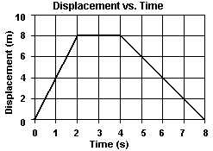
5. The graph represents the relationship between the displacement of an object and its time travel along a straight line. What is the magnitude of the object's total displacement after 8.0 seconds?

6. The graph represents the relationship between the displacement of an object and its time travel along a straight line. What is the average speed of the object during the first 4.0 seconds?

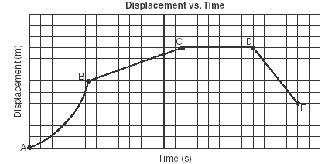
7. The displacement-time graph to the right represents the motion of a cart initially moving forward along a straight line.
During which interval is the cart moving forward at constant speed?

