Name: Period:
Equations of Motion 3: v_{f} = v_{i} + at
Show all work and include units
1. A child riding a bicycle at 15 meters per second decelerates at the rate of 3.0 meters per second squared for 4.0 seconds. What is the child's speed at the end of 4.0 seconds?

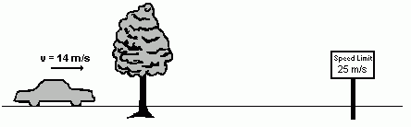
2. A car is traveling at a constant speed of 14 meters per second along a straight highway. A tree and a speed limit sign are beside the highway. As it passes the tree, the car starts to accelerate. The car is accelerated uniformly at 2.0 meters per second per second until it reaches the speed limit sign, 5.0 seconds later. What is the car’s speed when it reaches the speed limit sign? Is the car speeding or driving legally when it reaches the speed limit sign?

3. A ball dropped from rest falls freely until it hits the ground with a speed of 20 meters per second. The time during which the ball is in free fall is approximately

4. The speed of a wagon increases from 2.5 meters per second to 9.0 meters per second in 3.0 seconds as it accelerates uniformly down a hill. What is the magnitude of the acceleration of the wagon during this 3.0-second interval?

5. A ball is thrown straight downward with a speed of 0.50 meter per second from a height of 4.0 meters. What is the speed of the ball 0.70 second after it is released? [Neglect friction.]

