Name: Period:
Equations of Motion 8: Multiple Weapons of Math Destruction
Show all work and include units
1. The speed of an object undergoing constant acceleration increases from 8.0 meters per second to 16.0 meters per second in 10 seconds. How far does the object travel during the 10 seconds?

2. An object near the surface of planet X falls freely from rest and reaches a speed of 12.0 meters per second after it has fallen 14.4 meters. What is the acceleration due to gravity on planet X?

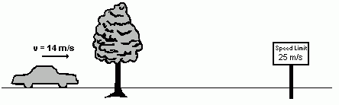
3. A car is traveling at a constant speed of 14 meters per second along a straight highway. A tree and a speed limit sign are beside the highway. As it passes the tree, the car starts to accelerate. The car is accelerated uniformly at 2.0 meters per second per second until it reaches the speed limit sign, 5.0 seconds later.
What is the distance between the tree and the sign?

4. A car having an initial speed of 16 meters per second is uniformly brought to rest in 4.0 seconds. How far does the car travel in this 4.0-second interval?

5. A car on a straight road starts from rest and accelerates at 1.0 meter per second2 for 10 seconds. Then the car continues to travel at constant speed for an additional 20 seconds.
a) Determine the speed of the car at the end of the first 10 seconds.

b) Calculate the distance the car travels in the first 10 seconds.

