Name: Period:
Speed-Time Graphs
Questions:
The graph below shows how three runners ran a 100-meter race.
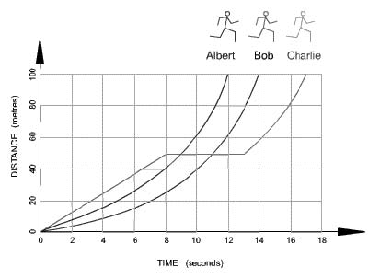

Which runner won the race? Explain your answer.

Which runner stopped for a rest? Explain your answer.

How long was the stop? Explain your answer.

How long did Bob take to complete the race? Explain your answer.

Calculate Albert’s average speed. (Figure the distance and the time first!)

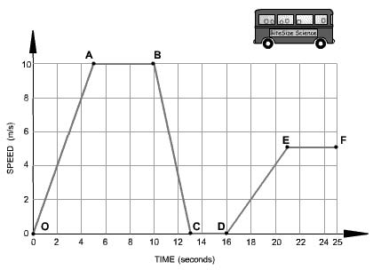
The graph below shows how the speed of a bus changes during part of a journey.

Choose the correct words from the following list to describe the motion during each segment of the journey to fill in the blanks.
- accelerating
- decelerating
- at a constant speed
- at rest

Segment 0 - A The bus is ______________________________. Its speed changes from 0 to 10 m/s in 5 seconds.

Segment A - B The bus is __________________________________of 10 m/s for 5 seconds.

Segment B - C The bus is ____________________________________. It is slowing down from 10 m/s to rest in 3 seconds.

Segment C - D The bus is ____________________________________________. It has stopped.

Segment D - E The bus is ________________________________________________. It is gradually increasing in speed.

