99 Pieces of Mental Luggage
To Bring To
The Earth Science Regents Exam
- The same substance always has the same density.
- As pressure increases, density increases.
- As temperature increases, density decreases.
- Water expands when it freezes.
- Most changes in the environment are cyclic.
- Water is densest at 4°C, when it is a liquid.
- The true shape of the earth is an OBLATE SPHEROID.
- The best model of the earth's shape is (looks like) a sphere.
- The altitude of Polaris equals your latitude.
- Latitude lines go east-west, but measure how far above or below the equator.
- Longitude lines go north-south.
- Longitude (and also time) is based on observations of the sun.
- USE THE REFERENCE TABLES!
- The closer isolines (contour-isobar-isotherm) are, the steeper the slope or gradient.
- The earth rotates west to east- counterclockwise as seen from N. Pole (in 24 hours).
- The earth revolves counterclockwise (365¼ days).
- All celestial objects APPEAR to move to the west.
- The moon has phases because of the angle at which we view its surface (Remember though: half of it is always lit).
- Planets APPEAR to go backwards (retrograde) as the earth passes them in space.
- Summer solstice - June 21 - 16 hours daylight - sun rises north of east-vertical ray on 23½° North, Tropic of Cancer.
- Winter solstice - December 21 - 8 hours daylight - sun rises south of east-vertical ray on 23½° South, Tropic of Capricorn.
- Equinoxes - Vernal - March 21, Autumnal - September 23, 12 hours daylight, sun rises due east, vertical ray on equator.
Key Dates to remember
- Equator always has 12 hours of daylight.
- The lower the altitude of the sun, the longer shadows it casts.
- There are two evidences that the earth rotates:
FOUCAULT'S PENDULUM: appears to change its direction of swing.
CORIOLIS EFFECT: deflects to the right in the N. hemisphere.
- Earth is closer to the sun in winter.
- USE THE REFERENCE TABLES!
- The closer a planet is to the sun, the faster it orbits.
- GEOCENTRIC: earth centered universe
- HELIOCENTRIC: sun centered
- Black absorbs / white reflects
- Conduction: heat transfer from molecule to molecule through collisions.
- Convection: heat transfer through fluids (gases, liquids) due to density differences.
Hot rises, cold sinks

- Radiation: heat transfer through space (vacuum) ex. light.
- Energy moves from source to sink, high to low.
- Kinetic energy: energy of motion, increases with velocity.
- Potential energy: stored or at rest, increases with height.
- There is NO temperature change at a phase change.
- Infrared has long wavelength.
- Carbon dioxide (CO₂) and water vapor absorb infrared radiation.
- Good absorbers of radiation are good radiators.
- Hottest part of the year is July/August (after June 21- time lag).
- Hottest part of the day is1-2 PM (after 12 noon- time lag).
- As temperature increases, air pressure decreases: hot air rises.
- As moisture content increases, air pressure decreases: clouds form in rising air.
- Air pressure decreases with altitude.
- 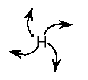Highs are cool and dry; Lows are warm and wet.
- 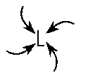Wind is due to air pressure differences and wind blows from high to low pressure.
- Use the Handy Dandy Earth Science Reference

Tables.
- Wind is named for the direction it is coming from.
- Highs are regions of divergence (clockwise)
- Lows are regions of convergence (counterclockwise)
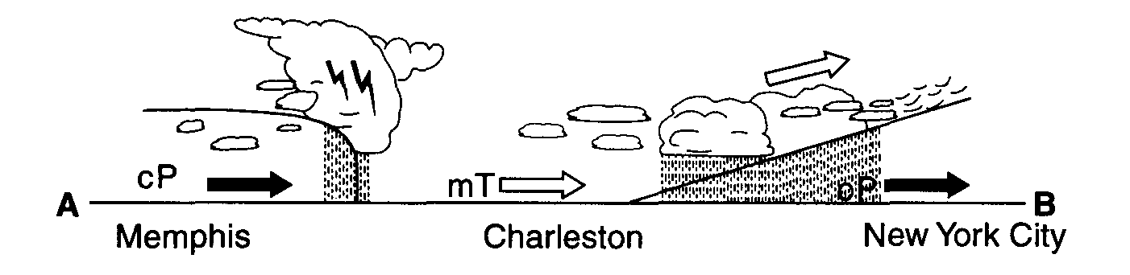
- The closer the air temperature is to the dew point temperature, the greater the chance of precipitation.
- Weather moves from west to east.
- Cold Front
- Warm Front
- Occluded Front
- Cold fronts move the fastest.
- Porosity (the amount of holes); it DOES NOT depend on particle size.
- Permeability (connection of holes); as particle size increases, permeability increases.
- Capillarity (movement of water upward); is highest in smallest particles.
- Ep (potential evapotranspiration- “strength of the sun”) depends on temperature.
- Water is stubborn- it is the hardest thing to heat up and cool down.
- Frost action works best where temps fluctuate above & below freezing.
- Chemical weathering favors warm wet climates.
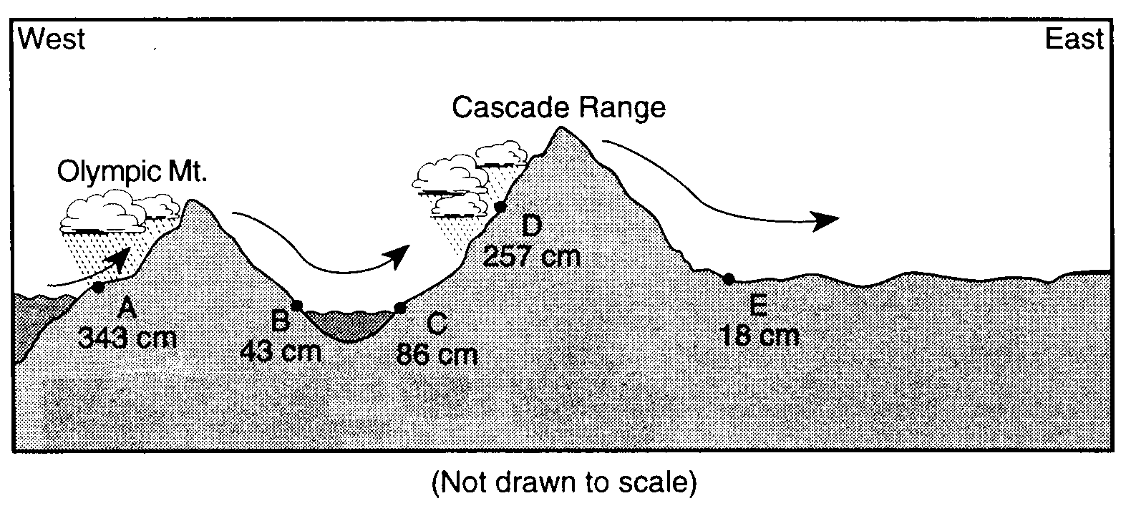
- Continental drift: fossils on opposite shores, puzzle fit of continents, tropical fossils in cold climates.
- Evaporation happens faster on large surface areas.
- Water bodies moderate temperature.
- Air cools as it rises.
- Orographic effect (Adiabatic changes)- Mountain barrier
- Gravity is behind all erosion.
- Streams are the number one agent of erosion.
- Stream velocity depends on slope and discharge (amount of water in the stream).
- Velocity is faster on outside of meander bend.
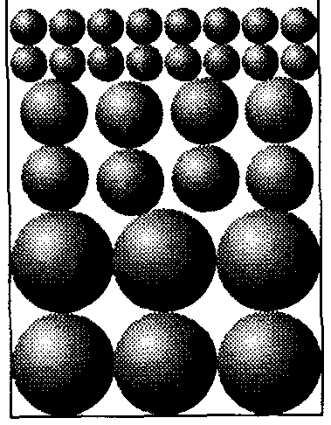
- Heavy-dense-round particles settle out first in water.
- Vertical sorting (graded bedding) biggest sediments on the bottom.
- Glacial sediments are unsorted, scratched, U-shaped valley.

- Stream deposits are sorted, round and smooth, V-shaped valley.
- Sedimentary rocks - strata = flat layers.
- Igneous rocks:
cools fastly - small crystals
cools slowly - large crystals
- Metamorphic rocks: banding-distorted structure.
- Mineral properties depend on internal arrangement of atoms.
- Silicon - oxygen tetrahedron: basic unit
- Isostasy: earth's crust in equilibrium
- Mid-ocean ridges: crust created
- Trenches: crust destroyed
- P-waves are phastest, phirst, push-pull, pass through everything.
- S-waves, slower, secondary, shake, solids only.
- Need 3 seismometer stations to locate an epicenter
- Undisturbed strata: bottom layer is oldest
- Intrusions and faults are younger than the rock they are in
- Unconformity: buried erosional surface
- Arid landscape: steep slopes
- Humid landscape: smooth, rounded slopes
- Memorize the "Dreaded 13 Must-know Earth Science Facts "
- Uranium²³⁸ dates old rocks
- Carbon¹⁴ dates recent, once living objects
- Convection currents in the mantle move the plates
- Always try to eliminate two answers
- USE THE REFERENCE TABLES!
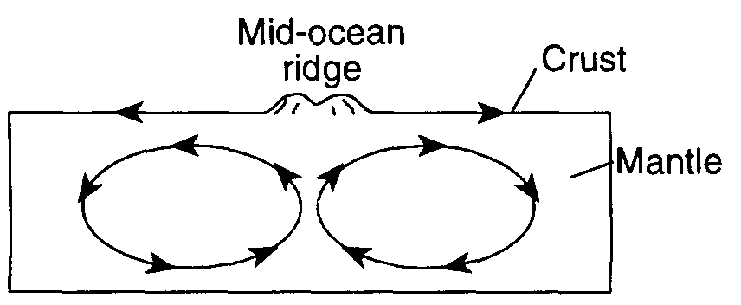
Convection Cell

