Name:________________

Mass vs. Volume of a Hershey Bar
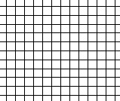
0

5

10

15

20

25

30

35

40

45

50

55

60
50
45
40
35
30
25
20
15
10
5
0
Volume (cm³)

Mass (g)

Squares | Mass | Length | Width | Height | Volume
12
6
3
2
1
1. What is the density of chocolate?

2. What would be the volume of 60g of chocolate?

3. What would be the volume of 35g of chocolate?

