Name:____________________ Period:_______

Determining Epicenter Distance

Directions: Use the sample seismograph data below to determine the distance to the earthquake.

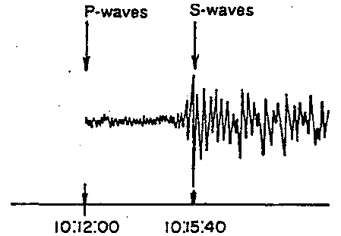
1. Determine the arrival time of the S-wave: ___________________
2. Determine the arrival time of the P-wave: ___________________
3. Subtract the two arrival times to determine the
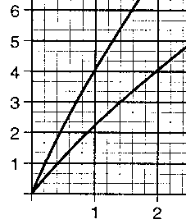
difference in arrival times: ___________________

4. On a piece of scrap paper, mark the difference in arrival times using the vertical axis on the graph to the right. (This is a small part of the chart on p. 11 of the Earth Science Reference Tables).
5. Place one mark on your scrap paper on the P-wave line. Keeping the scrap paper vertical, slide the scrap paper up along the P-wave line until the second mark on the scrap paper matches up with the S-wave line.
6. Follow the edge of the scrap paper down to the horizontal (distance) scale to determine the distance to the epicenter.

Epicenter Distance: ___________________

