Name:___________________ Period:_______
Latitude Longitude II
Place a dot at each latitude and longitude location. Connect the dots as you go.
Latitude | Longitude |  | Latitude | Longitude
6°N | 8°W |  | 33°N | 30°E
8°N | 12°W |  | 32°N | 32°E
12°N | 18°W |  | 14°N | 40°E
16°N | 18°W |  | 12°N | 42°E
19°N | 17°W |  | 10°N | 44°E
25°N | 15°W |  | 12°N | 61°E
30°N | 10°W |  | 5°S | 39°E
34°N | 8°W |  | 11°S | 41°E
36°N | 7°W |  | 15°S | 41°E
35°N | 6°W |  | 20°S | 33°E
35°N | 3°W |  | 25°S | 35°E
36°N | 0° |  | 30°S | 31°E
38°N | 10°E |  | 34°S | 26°E
34°N | 10°E |  | 35°S | 20°E
33°N | 15°E |  | 18°S | 12°E
31°N | 20°E |  | 12°S | 13°E
33°N | 21°E |  | 10°S | 14°E
34°N | 22°E |  | 3°S | 9°E
32°N | 29°E |  | 5°N | 9°E
 |  |  | 6°N | 8°W
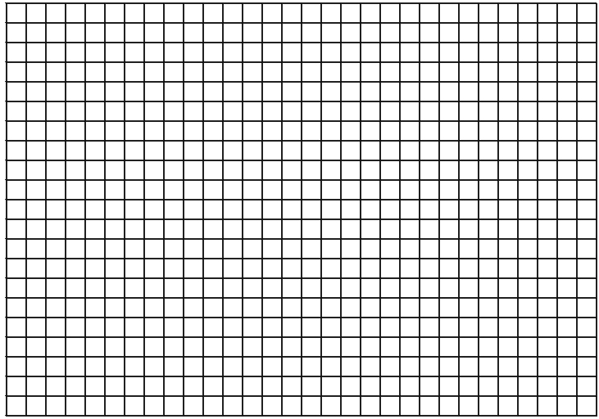
30°
25°
20°
15°
10°
5°
0
5°
10°
15°
20°
25°
30°
35°
40°
45°
50°
55°
60°
65°
70°
South North
40°
35°
30°
25°
20°
15°
10°
5°
0°
5°
10°
15°
20°
25°
30°
35°

West East

