Name:___________________ Period:_______
Latitude Longitude III
Place a dot at each latitude and longitude location. Connect the dots as you go.
Latitude | Longitude |  | Latitude | Longitude
0° | 80°W |  | 25°S | 49°W
3°N | 77°W |  | 28°S | 49°W
7°N | 77°W |  | 35°S | 55°W
8°N | 78°W |  | 38°S | 58°W
9°N | 77°W |  | 39°S | 63°W
8°N | 76°W |  | 42°S | 63°W
11°N | 75°W |  | 41°S | 65°W
12°N | 72°W |  | 45°S | 67°W
12°N | 70°W |  | 47°S | 65°W
10°N | 63°W |  | 50°S | 69°W
9°N | 60°W |  | 54°S | 70°W
7°N | 58°W |  | 55°S | 65°W
7°N | 54°W |  | 55°S | 70°W
4°N | 52°W |  | 50°S | 74°W
3°N | 51°W |  | 40°S | 74°W
2°N | 50°W |  | 20°S | 70°W
1°N | 50°W |  | 18°S | 71°W
2°S | 45°W |  | 15°S | 76°W
3°S | 40°W |  | 10°S | 78°W
5°S | 35°W |  | 5°S | 82°W
10°S | 34°W |  | 3°S | 82°W
13°S | 41°W |  | 1°S | 81°W
20°S | 40°W |  | 0° | 80°W
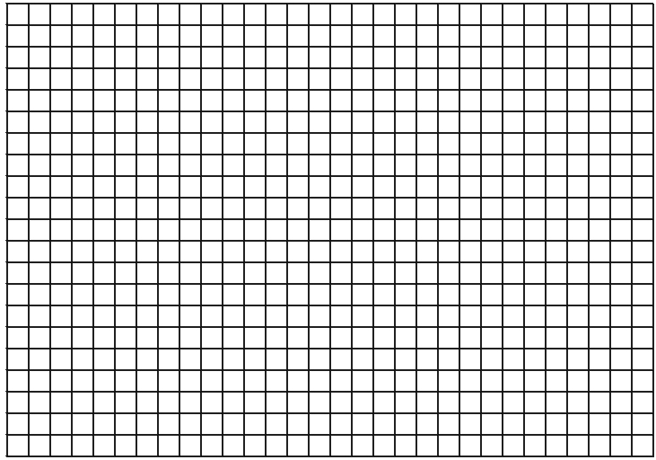
85°
80°
75°
70°
65°
60°
55°
50°
45°
40°
35°
30°
25°
South North

30°
25°
20°
15°
10°
5°
0
5°
10°
15°
20°
25°
30°
35°
40°

