Name:___________________ Period:_______
Latitude Longitude Skills

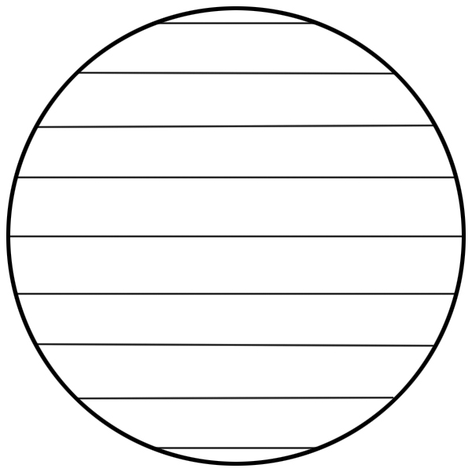
Latitude
A 80º
B 60º

C 40º

20º

G 0º

20º
D 40º

E 60º
F 80º

A is _____ degrees _______ of the equator.
B is _____ degrees _______ of the equator.
C is _____ degrees _______ of the equator.
D is _____ degrees _______ of the equator.
E is _____ degrees _______ of the equator.
F is _____ degrees _______ of the equator.
G is _____ degrees. It is the ___________ .
Circle an answer:
A is ( north south ) of F.
D is ( north south ) of F.
E is ( north south ) of F.
A is ( north south ) of C.
B is ( north south ) of A.
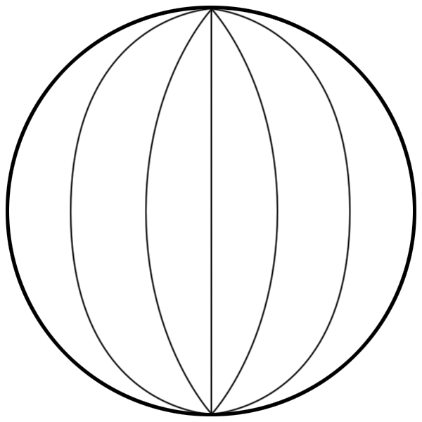
Longitude

90º 60º 30º 0º 30º 60º 90º

A B C D E F G

C is _____ degrees _______ of the Prime Meridian.
B is _____ degrees _______ of the Prime Meridian.
E is _____ degrees _______ of the Prime Meridian.
F is _____ degrees _______ of the Prime Meridian.
G is _____ degrees _______ of the Prime Meridian.
A is _____ degrees _______ of the Prime Meridian.
Circle an answer:
A is ( east west ) of the Prime Meridian.
B is ( east west ) of the Prime Meridian.
E is ( east west ) of the Prime Meridian.
F is ( east west ) of the Prime Meridian.
G is ( east west ) of the Prime Meridian.

Latitude and Longitude
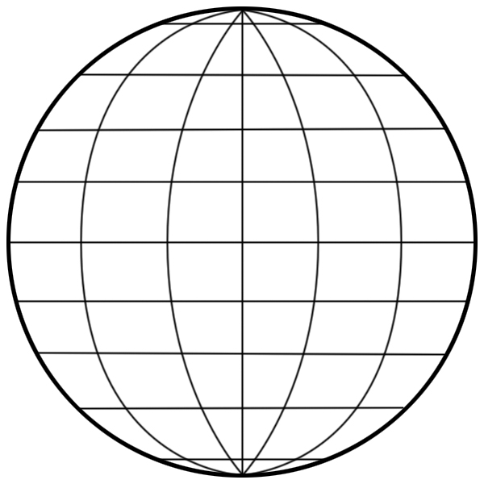
80º
A 60º

B C 40º

20º

0º

D 20º
F 40º

E 60º
80º

90º 60º 30º 0º 30º 60º 90º

A is _____ degrees ( N S ) latitude.
A is _____ degrees ( E W ) longitude.
B is _____ degrees ( N S ) latitude.
B is _____ degrees ( E W ) longitude.
C is _____ degrees ( N S ) latitude.
C is _____ degrees ( E W ) longitude.
D is _____ degrees ( N S ) latitude.
D is _____ degrees ( E W ) longitude.
E is _____ degrees ( N S ) latitude.
E is _____ degrees ( E W ) longitude.
F is _____ degrees ( N S ) latitude.
F is _____ degrees ( E W ) longitude.

