Name:_________________________ Period:_____________
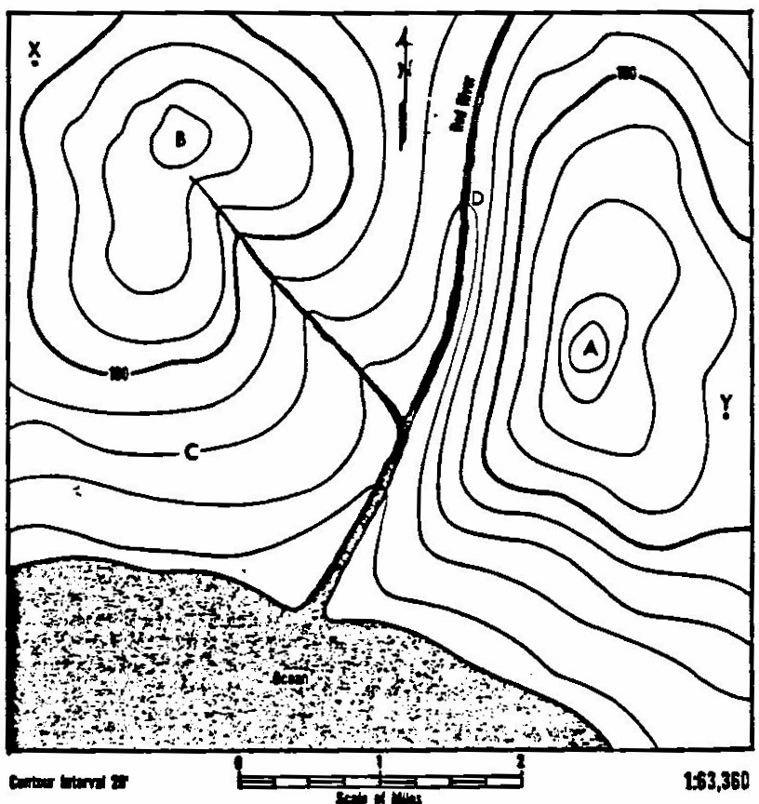
Red River Contours

100

100

Ocean

1. What is the contour interval of this map?
2. Number all the contour lines.
3. What is the scale of miles of this map?
4. By means of the scale, measure the distance from the top of hill B to the top of hill A.
5. Which side of hill A has the steepest slope?
6. How can you tell whether a land form has steep or gentle slopes?
7. In what direction from hill A is hill B?
8. What is the elevation above sea level of hill A?
9. a) Which of the two hills is higher?
b) How much higher?
10. If you climbed to the top of hill B from C, how many feet would you climb?
11. In what direction is the Red River flowing?
12. How does a contour map show the direction in which a river is flowing?
13. Shade the area on the map which would be under water if the sea level rose 40 feet.
16. Calculate the gradient of the Red River from point D to the ocean.

