Geologic History of Long Island Sound

Ralph Lewis, Geologist,
Connecticut Geological and Natural History Survey,
Connecticut Department of Environmental Protection
The earliest beginnings of Long Island Sound can be traced to a period of great continental collisions, lasting from about 500 million years ago to about 250 million years ago, that resulted in the formation of the supercontinent of Pangaea. Pangaea survived as a supercontinent for roughly 50 million years. By around 200 million years ago, a different set of forces was working to tear the joined landmasses of Pangaea apart. The tearing apart, or rifting, of Pangaea set the stage for the development of Africa, North America, and the Atlantic Ocean as we know them. The geologic foundation of Long Island Sound began to take shape at this time as well.
Africa and North America split apart in a configuration that left the Appalachian Mountains as the western border of the emerging Atlantic Ocean basin. Over the next 200 million years, weathering took its toll on these once majestic mountains and only their core survives today. Much of the sediment that was created during this long erosive process was deposited along the edge of the expanding Atlantic Ocean. By about 3 million years ago, a seaward-thickening wedge of sediment buried most of the hard, crystalline, Appalachian Mountain rocks that formed the eastern flank of North America. Today we know the landward, above-water portion of this wedge as the Atlantic coastal plain. Its thicker, submerged, offshore component forms the continental shelf (Fig.1).
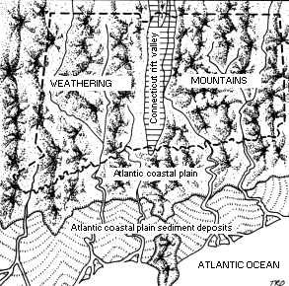
Fig.1 : The building of the coastal plain and continental shelf of Connecticut.
Up to about 3 million years ago, when the North American glaciations probably began, the major force that worked to erode the top of the coastal-plain sediment wedge was stream action. Long Island Sound occupies a lowland that was initially carved into the coastal-plain by rivers, and subsequently glacially modified. The combined erosive effects of the ice advances included re-exposing, wearing down and smoothing the crystalline Appalachian rocks that now form the Connecticut coast, cutting back and sculpting the remaining coastal plain wedge (which now forms the foundation of Long Island), and redistributing eroded material in the form of glacial deposits.
The last ice advance (Wisconsinan) started in Canada about 85,000 years ago, reached Connecticut about 26,000 years ago and began to wane on Long Island about 21,000 years ago. The southernmost extent of the Wisconsinan glacier is marked along the middle of Long Island by piles of glacial debris called a "terminal moraine." Present evidence suggests that the glacier modified but did not entirely alter the pre-Wisconsinan configuration of the Long Island Sound basin. When the Wisconsinan glacier was at its maximum, sea level was about 91 meters (300 feet) lower than it is today, and the shoreline was 80 to 110 kilometers (50 - 70 miles) south of Long Island.
By about 20,000 years ago, the glacier could no longer maintain itself at its terminal position because it was melting faster than new ice was being pushed south. As the ice front receded from its southernmost position, it stuttered and paused several times. At each of these pauses (recessional positions), it left a pile of glacial debris known as a recessional moraine. The bulk of the above-water portions of Fishers Island, Plum Island, and northernmost Long Island are parts of the Harbor Hill-Roanoke Point-Fishers Island-Charlestown recessional moraine.
Because this moraine stood high on the southern margin of the Long Island Sound basin, it made an ideal dam for meltwater from the glacier. As the ice continued to retreat northward, glacial Lake Connecticut formed north of the moraine dam (Fig. 2).
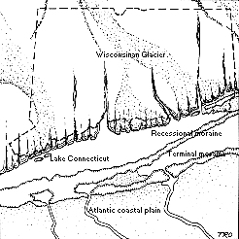
Fig. 2 As the Wisconsinan Glacier retreated northward, glacial Lake Connecticut formed north of the Harbor Hill-Roanoke Point-Fishers Island-Charlestown recessional moraine. Sea level was about 90 meters (300 feet) lower than it is today.
The glacier paused briefly and deposited small recessional moraines near Old Saybrook, Madison and Branford along the Connecticut shore. The Captain and Norwalk Islands are also moraine segments. The expanding glacial lake eventually grew to be about the same size as present-day Long Island Sound, and may have been connected with similar freshwater lakes in Block Island Sound and Buzzards Bay. The fairly shallow depth (average 20 meters or 64 feet) of today's Long Island Sound is attributable to the fact that Lake Connecticut was nearly filled in by clay sediments brought southward by the glacier.
By about 15,000 years ago, the glacier had retreated out of the State and glacial Lake Connecticut had just about completely drained to the sea through an outlet in the moraine dam at the Race (between Fishers and Long Islands). The land had been pushed down by the weight of the glacier, and it was "rebounding" upward in response to the absence of the ice. The upward "rebound" of the land was accompanied by a rise in sea level as water from the melting glacier returned to the sea. For an unknown period, there was a complex interplay between the rising sea and the rising land. During this time, the sea probably entered the Long Island Sound basin through the Race.
A shallow sea, at a stable elevation of about -40 meters (-130 feet), probably existed in the basin from around 13,500 years ago to around 9,000 years ago. After that the rate of "rebound" appears to have lessened, and sea-level rose continuously relative to the land. Current evidence indicates that the rate of relative sea-level rise decreased about 5,000 to 3,000 years ago (Fig. 3).
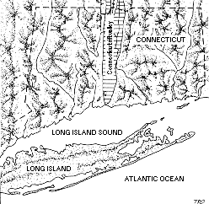
Fig. 3: As the rate of sea level rise slowed, the Long Island Sound estuary assumed its present shape.
This event marked the birth of the Long Island Sound which we all recognize. Sedimentation started to keep pace with sea-level rise, and marshes began to develop along the margins of the estuary. Since wave energy is fairly low in the Sound, wave action has not greatly modified the shore, and the Connecticut coast is very much a reflection of the shape of the land before it was drowned by the sea.
SUGGESTED READING
Bell, M. 1985. The Face of Connecticut: People, Geology and the Land. Connecticut Geological and Natural History Survey Bulletin No. 99. Connecticut Department of Environmental Protection. Hartford. 215 pp.
Lewis. R.S., and J.R. Stone,. 1991. Late Quaternary Stratigraphy and Depositional History of the Long Island Sound Basin: Connecticut and New York. Journal of Coastal Research Special Issue No. 11: 1-23.

June 21, 1997 / DEP's Tidal Wetland Restoration Program / webmaster@po.state.ct.us

QUESTIONS
- How did Pangea begin the development of the Long Island Sound.

- What geologic event had the greatest effect on the development of the Long Island Sound?

3. Explain what has happened to the Appalachian Mountains over the last 300 my.

4. Construct a scenario for the Long Island Sound over the next 1 million years.

