Name:__________________
Density Lab Station 1
Measuring Density
At this station you will measure and calculate the density of different materials.
Write the equation for density:
Station 1 counts
as one lab worth 100 points

What are the units for volume of a solid material?________

What are the units for mass of a material?____________

Fill in the chart below.
Item Description | Mass | Volume | Density
To measure the density to a liquid:
- Measure and record the mass of an empty DRY graduated cylinder. Write it three times.
- Add some liquid to the cylinder and accurately record its volume (mL).
- Measure and record the mass of the cylinder with the liquid.
- Subtract the empty cylinder from the filled one to get the mass of just the liquid.
- Calculate the density just as before.
- Empty the cylinder and refill it to a different level.
Volume Number | Mass empty cylinder | Mass water & cylinder | Mass of liquid | Volume of liquid | Density.
1
2
3
Continued on the next page.
Make a line graph of the volume vs. the mass of the liquid volume. Make a line graph connecting the three points.

Volume
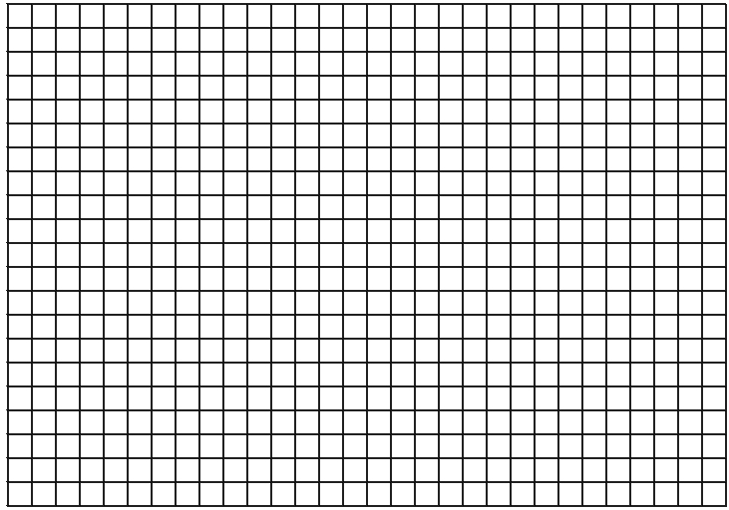
Mass
Name:__________________
Density Lab Station 2
Station 2 counts
as one lab worth 100 points
Measuring Density of a Cylinder and a bar
Write the equation for density.

Part I
The equation for calculating the volume of a cylinder is:
πr²h
Where r is the radius and h is the height of the cylinder.
Measure the radius of the cylinder:
Measure the height of the cylinder:
Calculate the volume of the cylinder (show all work below the table):

Fill in the chart:
Sample | Volume | Mass | Density
1
2
3
4
5
Workspace:

Part II
In this part, you will calculate the density of a bar that will change its size. To preserve the integrity of the bar it is double wrapped in paper and foil.
- The pan of the electronic balance needs a clean piece of paper that has been cut or torn to just cover the top. Once the paper is on the pan, re-zero the scale so that it reads zero grams.
- Remove the wrapping of the bar and measure the length, width and height to calculate the volume. (Assume that the bar is a perfect block with no gaps or spaces.)
- Measure the mass.
- Break the bar in half so that the bar has two halves each with six and six squares.
- One half of the bar can be removed from the experiment and you can get rid of it any way that you want (wink wink).
- Break the six-squared piece in half and discard one set of three and repeat the calculations.
- Break off ONLY one square and measure the density of the remaining two.
- Break the last two apart and measure the density of the last square.
Number of squares | Mass | Volume | Density
12
6
3
2
1

Make a line graph of mass vs. volume.

Volume
Mass
Name:__________________
Density Lab Station 3
Station 3 counts
as one lab worth 50 points
Measuring Density of a Material that Changes Its Volume

Write the equation for density.

Materials needed:
Plastic syringe (no needle)
Clean sheet of computer paper
Three “test pilots” for each student

When you measure the size of the “test pilot” you will see that the measurements are approximately 1cm in height, width and depth. That makes the volume approximately 1cm³. For the purposes of this activity, that number will be accurate enough (we will also assume that the “test pilot” is a cube).

Place the pilot into the syringe, close the syringe until it just touches the pilot- but do not squish it.
Place your thumb over the opening in the syringe so as not to allow any air into it. Expand the air in the syringe by pulling the plunger MOST of the way out.
Approximate the new length, width and height of the pilot.

Mass before test:______________
Volume before test:_____________
Density before test:_____________

Mass after test (same as before):________________
Volume after test (LxWxH):________________
New density:_______________

Repeat the activity but this time compress the air by opening the syringe, place your thumb over the opening and squeeze- but DO NOT SQUISH THE PILOT.

Mass before test:______________
Volume before test:_____________
Density before test:_____________

Mass after test (same as before):________________
Volume after test (LxWxH):________________
New density:_______________

Questions on next side.

If a material expands and does not change its mass, what happens to its density?

If a material contracts and does not change its mass, what happens to its density?

If a helium balloon rises high into the air, the air gets thinner and lighter. Shouldn’t it reach a point where the air has the same density as the helium? Explain how the balloon can continue to rise anyway. (Hint: does the density of the air outside the balloon remain the same?)

Name:__________________
Computer Lab Station 4

Motion Graphing
Station 4 counts
as one lab worth 50 points

Materials:

Laptop
PASCO Interface Box
Motion Sensor
Computer Cable
Interface power cord

Procedure:
- Connect the Interface box as shown by Mr. Medina (do not screw the cable into the port).
- Turn the power on to the Interface box.
- Turn on the Computer.
- When boot-up is complete, double-click on
“Data Studio”
“Create Experiment” You should see a picture of the interface box.
Choose the “Motion Sensor”.
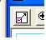
In the lower left corner “Displays”, double-click graph.
Maximize the graph so it takes up most of the screen.
When you begin the data collection you will hit “Start” on the tool bar at the top.

By moving your hand or a book, try to reproduce the graphs shown below. Then describe, in detail, what you had to do to make the graph. After each graph, clear data by going to “Experiment”, “Clear all data”.
1.
What did you do?

2.
What did you do?
3.
What did you do?

4.
What did you do?

What did you do?
5.

6.
What did you do?

What did you do?

- 7.
Name:__________________
Computer Lab Station 5
Station 5 counts
as one lab worth 50 points

Graphing Using Excel
Re-Create the graph below EXACTLY as you see it. It has to be exact!
If you are on a wireless computer, print out your chart.
Here’s the data you’ll need (you do not need to show this data chart):
Month | 1 | 2 | 3 | 4 | 5 | 6 | 7 | 8 | 9 | 10 | 11 | 12 | 13 | 14 | 15 | 16 | 17 | 18 | 19 | 20 | 21
Concentration | 4 | 8 | 12 | 11 | 15 | 19 | 18 | 22 | 26 | 25 | 29 | 33 | 32 | 36 | 40 | 39 | 43 | 46 | 46 | 50 | 54

