Name:__________________ Period:_________
Epicenters III
Fill in the data chart with the information from the seismograms.
Times shown are hours and minutes. Seconds are not shown.
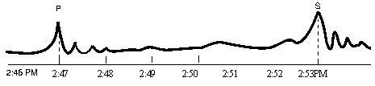

New York

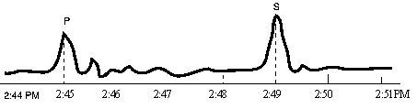
Louisville

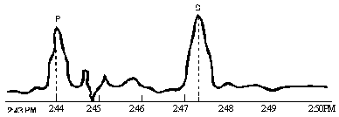

Pittsburgh

Seismograph Station | Arrival (clock time) |  | Difference in arrival time  (min & sec) | Distance to epicenter
Seismograph Station | “P” wave | “S” wave | Difference in arrival time  (min & sec) | Distance to epicenter
New York
Louisville
Pittsburgh

