Name:__________________ Period:_________
Finding Epicenters IV
Fill in the data chart with the information from the seismograms.
Times shown are hours and minutes. Seconds are not shown.
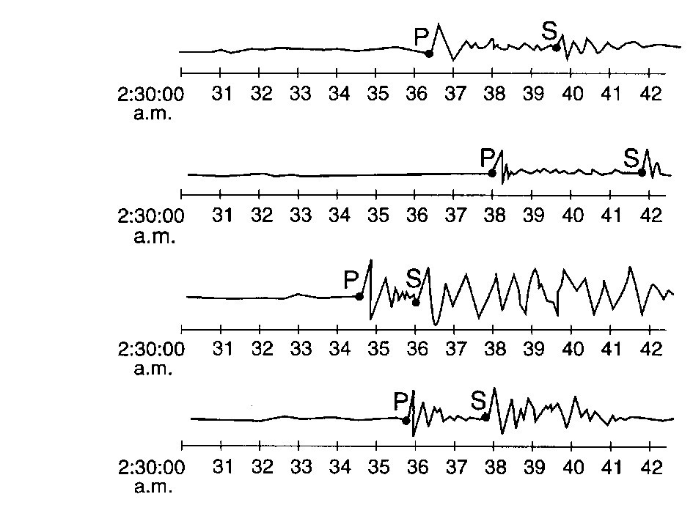
Tampa
Denver
Chicago
Oklahoma City
Seismograph Station | Arrival (clock time) |  | Difference in arrival time  (min & sec) | Distance to epicenter
Seismograph Station | “P” wave | “S” wave | Difference in arrival time  (min & sec) | Distance to epicenter
A
B
C
D

Turn over to plot the epicenter
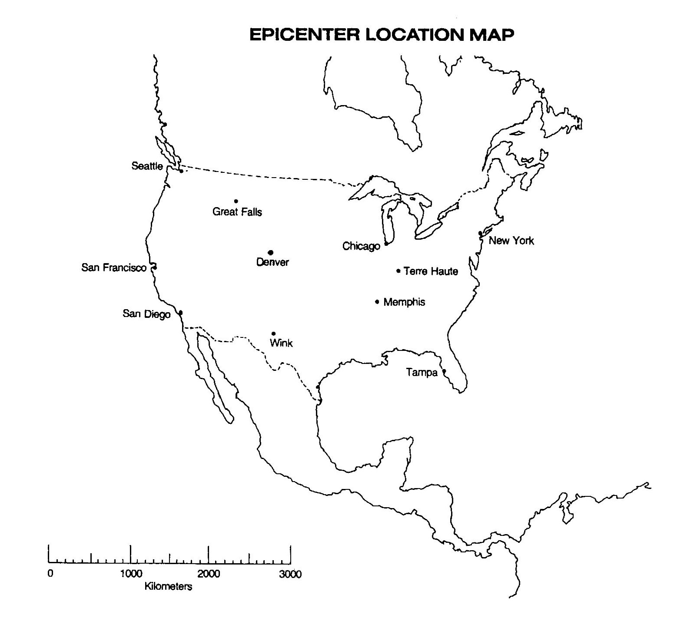
.
Oklahoma
City

