Name:________________ Period:__________
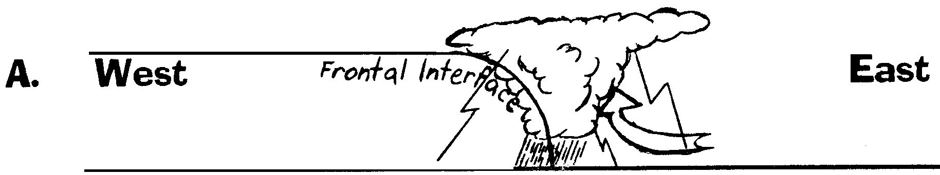
Fronts

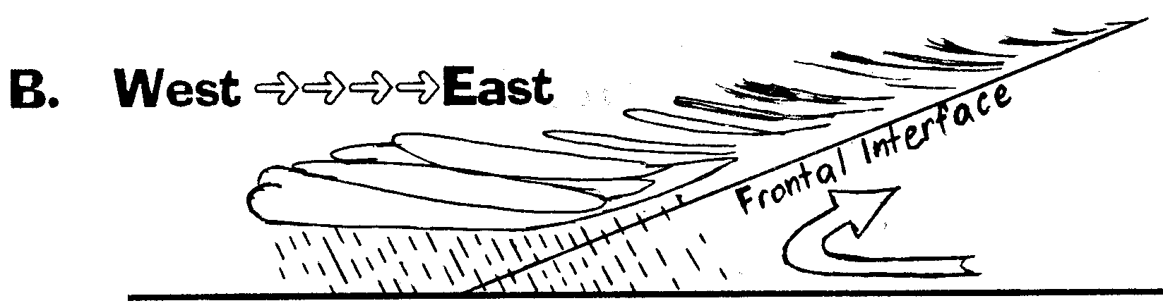

1. Which diagram shows a cold front?
2. Which diagram would have a symbol like this:

3. Which diagram would have a symbol like this:

4. Which diagram shows a warm front?
5. Which diagram shows stratus type clouds?
6. Which front would be preceded by cirrus clouds and perhaps show a "ring" around the sun or "halo" about the moon?
7. Which diagram shows cloud cover over the greatest number of miles?
8. Which diagram shows the cumulonimbus cloud?
9. Which front would have more hours of precipitation?
10. Which front, or fronts, usually move in a West to East direction?
11. In which front would you be more likely to find a thunderstorm?
12. In which front would you be more likely to find a squall line and a sudden change in wind direction?

1.________
2.________

3.________

4.________
5.________
6.________

7.________

8.________
9.________

10._______

11._______

12._______
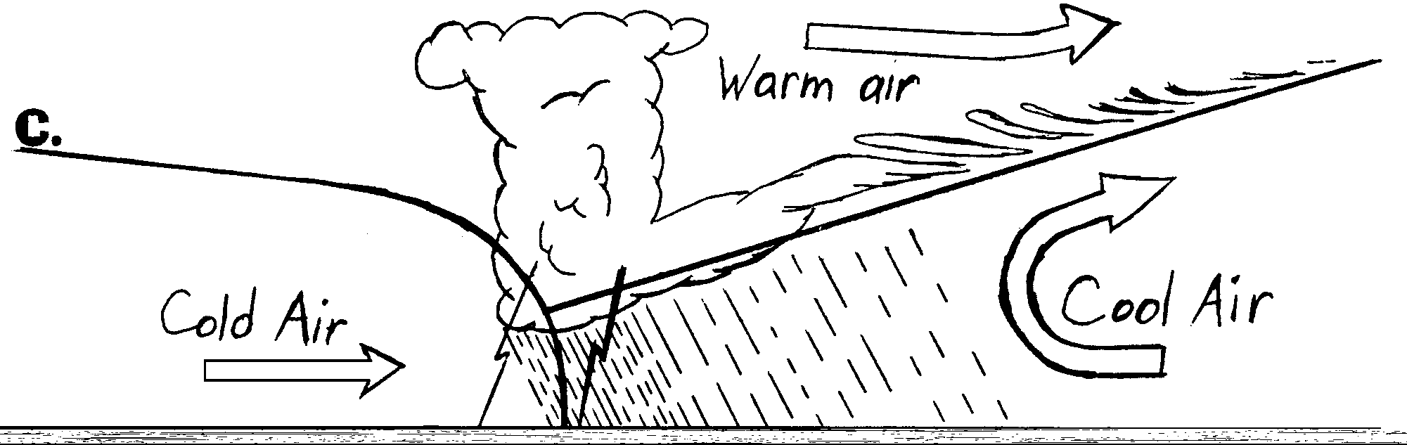

13. The above diagram represents the weather conditions associated with what kind of front?

14. In the space provided below draw how this front would look on a weather map.

