Name:__________________ Period:__________

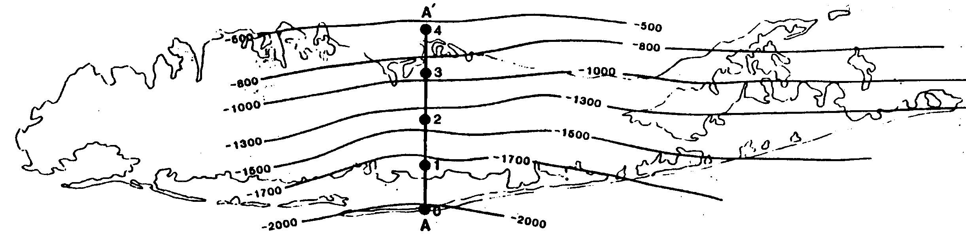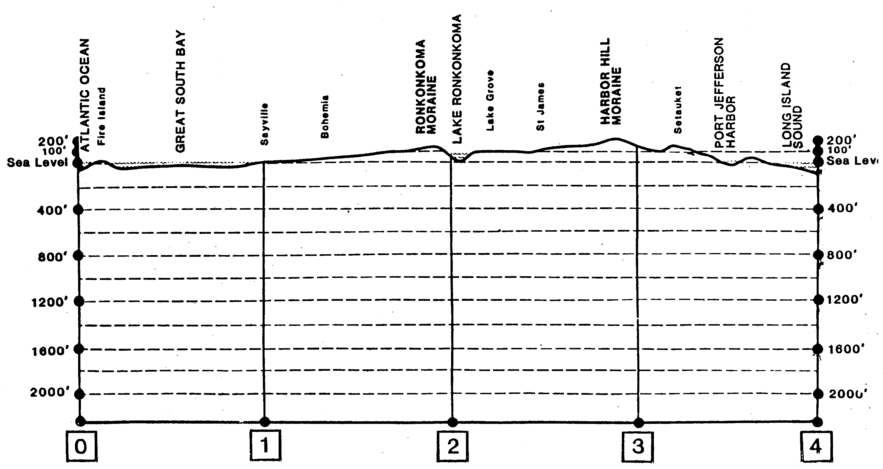
Using the map above, which shows the depth below the surface to the bedrock, make a cross section of Long Island on the map below.

