Name:________________ Period:__________
Isobars
- Uncode each pressure
- Find and label the following isobars: 996, 1000, 1004, 1008, 1012, 1016
- Label the H and the L
- Extend the wind arrows to show direction.
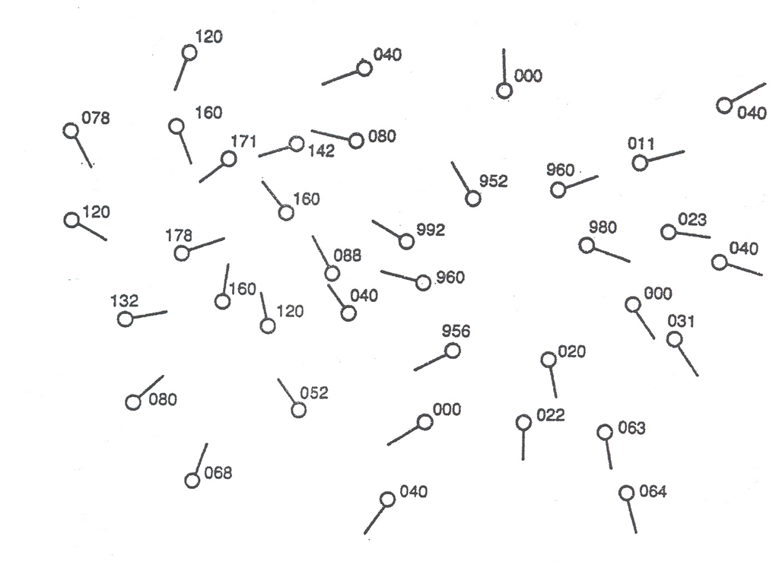

- How do winds move around an H?

- How do winds move around an L?

- Where is the wind the greatest?

- Winds travel from _______ to ________ .

