Name:____________________________ Period:__________
This counts as a lab in your folder
Radioactive Decay
In other investigations you will determine relative age. In this investigation you will determine absolute age. Relative age is the order in which things happen. Absolute age is the actual age of something, in years. In geology, relative age is finding out whether one rock, or fossil, formed before or after another rock, or fossil. Absolute age is finding out exactly how long ago an event took place.
After radioactivity was discovered, at the end of the 19th century, scientists developed a method for determining the actual age of some rock layers. They found that certain elements decay at measurable and predictable rates. They call these radioactive elements. Each radioactive element decays at a fixed rate. The rate is unaffected by temperature and other environmental factors. Therefore these elements are used as radiometric clocks.
In this investigation you will construct a model for radioactive decay. Unfortunately, radioactive dating does not work for all rocks. It works only when a radioactive element was present when that rock was formed.
Problem: How can you determine the absolute age of a sample of a rock?
Objectives: At the end of this investigation the student should be able to:
1. List the assumptions needed for a reliable radiometric date.
2. Describe how daughter/parent decay is used to determine age of a rock.
3. Determine the age of a sample, given the half-life, the amount of undecayed radioactive element in the sample, and the amount of radioactive element that was present originally.

Materials: A container with 160 identical objects (coins or other marker) and a calculator.

Procedure
Phase I:
The first part of this investigation requires teams of 4 or 5 students. One student becomes the investigator. The other 3 or 4 become radiometric clocks.
1. Lay out all 160 markers on the table.
How it’s going to work (but not yet!): After the investigator leaves, the group will select a random number between 2 and 8. That will be the number of clocks the group will use. On his or her turn each clock must take HALF of the markers that remain on the table. The clocks will keep taking turns until the total number of turns for the group is the random number they selected earlier.
2. Send the investigator away and then take turns removing the markers.
3. Call the investigator back and she or he must figure out how many clocks took markers.
How many clocks took markers?

2. Suppose that there were five clocks in the game. How many markers would each one take?
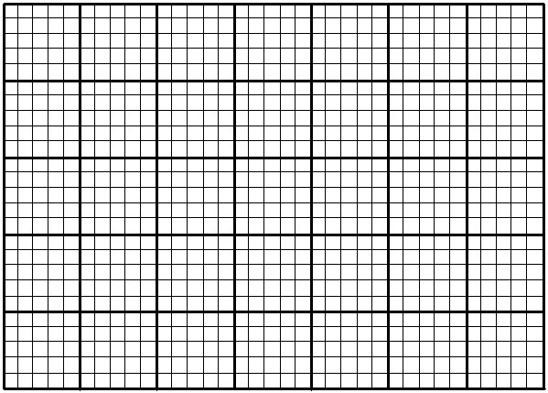
Illustrate your answer on the graph below.
Markers Remaining
0 1 2 3 4 5 6 7
Half-lives

Phase II. Dating an Event with U/Pb, ThlPb, K/Ar, or Rb/Sr
It would be nice if we only had to count the atoms of parent material. Or even if we had to count just the daughter product, which is what we call the decay material. However, in a real situation, we have no way of knowing how much parent we started with. We can only learn that by counting both parent material and daughter product.
Thus, we need to establish a ratio of daughter to parent. The ratio is established by dividing the amount of daughter by the amount of parent present. In the beginning there is no daughter product, so the ratio is 0. After one half-life, there is the same amount of parent and daughter, so the ratio is 1/1. After two, the ration is 3/1. Plot these ratios on the graph. Then calculate the ratio after 3, 4, and 5 half lives. Plot these on the graph. Connect the points with a smooth curve.
0 1 2 3 4 5 6 7
Half-lives
Markers Remaining
0 1 2 3 4 5 6 7
Half-lives

Step 1. Pick out 160 markers. They allow only two options; heads or tails (white or black). This represents the two radioactive options; parent or daughter.
Step 2. The white side will represent the parent material and the black will represent the decay (daughter) product.
Step 3. Plot the ratio of daughter to parent before you start on the data table.
Step 4. Mix the markers by gently shaking them in a container. Pour the markers onto the table. Count the parent and daughter markers. Record the numbers in the data table. Then calculate the ratio. Plot the ratio on the graph for 1 half-life.
Step 5. Leave the decayed daughters (black) on the table. Mix only the undecayed parent material. Shake them gently and pour them onto the table. Count the parent and daughter markers. Record them in the table. Calculate the ratio.
Step 6. Continue, until no more parent pennies remain.
Step 7. Compare the predicted decay curve with the actual decay curve.

Half-lives | # of daughter markers | # of parent markers | Ratio  Daughter/Parent
0 (start)
1
2
3
4
5
6
7
8
9
10
Ratio
Daughter/Parent
0 1 2 3 4 5 6 7
Half-lives

¹⁴C dating is easily done with this curve. The geochemist determines how much total carbon is present in a sample. Then, he or she can calculate the amount of ¹⁴C that was present at the beginning. Next, the geochemist measures the amount of ¹⁴C remaining. Divide the amount remaining by the amount present at the beginning. Compare this percentage to the half-life curve to determine how many half-lives were used.

1. If the percentage = 50.0%, how many half-lives were used?___________

2. If the percentage = 12.5%, how many were used? __________________

3. If the percentage = 3 3.3%, how many were used? __________________

4. Multiply the number of half-lives used, by 5,700 yrs. That is the half-life for ¹⁴C. The resulting product is the age of the sample in years before present (yBP).

a. What is the age for 50.0%? ______________

b. What is the age for 12.5%? ______________

c. What is the age for 33.3%? ______________
5. What is the difference between a ¹⁴C date and a U/Pb date? How does process differ? (if more space is needed, use the back)

6. How does a geochemist insure a reliable date? What conditions must be met? (if more space is needed, use the back)
Note about carbon dating: many critics say that radiometric dating is inaccurate and is not a reliable means for measuring the date of the Earth. The ratio of Carbon-12 to Carbon-14 (and therefore can complicate the ratio between parent/daughter) can vary throughout history due to fluctuations in solar intensity. This is a unique problem to Carbon and does not affect the other radioisotopes used for dating. As a result, the other radioisotopes are used to calibrate ¹⁴C, thus refining its accuracy.

