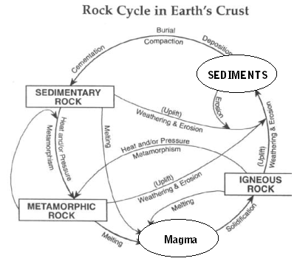Name:________________ Period:_____________
- As magma cools, it forms _______________ rock by the process of ________________.
- Igneous rocks can form _______________ , _______________ and _______________ rocks.
- Sediments form _______________ by the process of ________________ __________________________________________________________ .
- Sediments form from the process of _____________________________________________ .
- Sedimentary rocks can form _______________ , _______________ and _______________ rocks.
- Which process changes igneous rock into metamorphic rock?
- Which process changes sedimentary rock into igneous rock?
- Which process changes metamorphic rock into sedimentary rock?
- Metamorphism involves the addition of _______________ and _______________ to pre-existing rocks.
- Compaction & cementation of sediments forms _______________ rocks.
- Subjecting sedimentary rocks to extreme heat & pressure forms _______________ rocks.
- Solidification of molten materials forms _______________ rocks.
- Deposition and burial of sediments forms ___________________ rocks.
- Deposited sediments may be particles of which types of rock?
- Heat & Pressure acting on igneous rocks forms ___________________ .
- Solid magma forms ______________________________ .
- In order to form magma, what must happen to sedimentary, metamorphic or igneous rocks?

- For weathering & erosion to occur, what process will the rock usually go through first or at the same time?

- Can sedimentary rock form directly from metamorphic rock? Explain your answer.

