Name:________________ Period:________ Partners: ______________
______________
Satellite Mapping Activity
______________
______________
______________

You are in a satellite flying above Earth’s surface. Your goal is to map a portion of Earth’s surface using the latest in radar technology. The radar device you have been given is a range finder which automatically measures the distance from your satellite to the surface. You are to scan the land, map the surface with contour lines, and create a 3-dimensional map of the surface.

- Set up your equipment as demonstrated by your teacher.
- Scan each grid section to measure the distance from the satellite. Round all measurements to the nearest tenth of a meter.

Note: since the land is “upside down” the highest peaks will give you a smaller distance than the valleys. In order to correct this all values are to be subtracted from 3m.
For example: A distance of .5m will be converted to 2.5m (3m - .5m = 2.5m) which is the height of the land.

- On your map, be sure to locate positions X, Y, Slope River & Lake Arseeum.
- Once you have a complete set of data for the portion of the Earth you are scanning, share the data with your teammates.
- Create contour lines by connecting equal values. Use a contour interval of _______m.
- Once your contour map is complete, get a laptop computer and input the elevation data into Excel to create a “surface plot” of the land.

Calculate the gradient of Slope River from X to Y. Show all work.
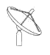
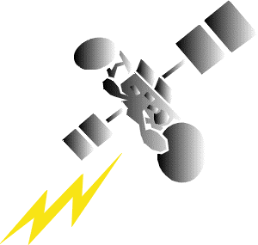
Name: Fred Period: 5
This is the format of your report.

Title

Data Table (copy & paste it here)

Your Graph Goes Here.

(Keep the colors tame- It will be printed)

Calculate the gradient between x and y here.
Name:______________________ Period:_____________
Partners:_______________
_______________
_______________
_______________

6 | C | D | E | F | G | H | I | J | K
7
8
9
10
11
12
13
14
15
16

