Name:_______________ Period:________
Seasons and Daytime
Use the diagrams on the opposite side of this sheet to do the two following activities.

I. Seasons
- Draw arrows indicating the direction of the Earth’s rotation and revolution.
- For each location of the Earth, label the season and date.

II. Amount of Night and Day at Various Latitudes
For each diagram of the Earth, perform the following:
- Label the season and date on the blank line.
- Label the North and South Poles.
- Using curved arrows, show the direction of rotation.
- Draw and label the terminator and lightly shade the dark side with a pencil.
- Label the number of hours of daylight for each of the following:
North Pole, South Pole, Equator, Long Island.
- Draw a small picture of a person standing where the sun is directly overhead at noon.
- Draw a small picture of a person standing where the sun is on the horizon at noon.
- Seasons
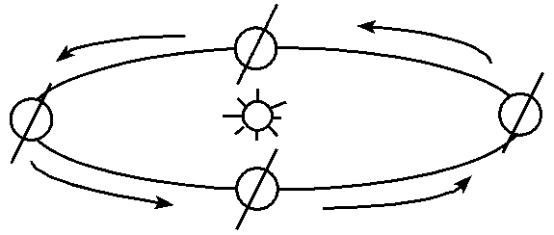
- Amount of Night and Day at Various Latitudes
A.______________
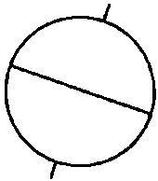
B.______________
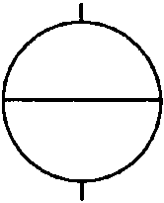
Sun's Rays
C.______________
