Name_________________________ Period:_____________

Sequence of Events Practice #1
List the events needed to make the pattern of rock layers shown below in order from first (oldest) to last (youngest).
Assume that sedimentary rocks are deposited under water and that erosion happens above water.
Use your Handy Dandy Earth Science Reference Tables to identify the names of the rocks.
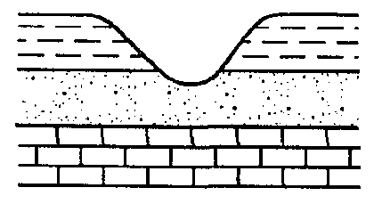
- ___________________________________
- ___________________________________
- ___________________________________
- ___________________________________
- ___________________________________

Sequence of Events Practice #2
List the events needed to make the pattern of rock layers shown below in order from first (oldest) to last (youngest).
Assume that sedimentary rocks are deposited under water and that erosion happens above water.
Use your Handy Dandy Earth Science Reference Tables to identify the names of the rocks.
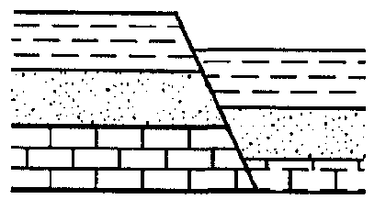

- ___________________________________
- ___________________________________
- ___________________________________
- ___________________________________

Sequence of Events Practice #3
List the events needed to make the pattern of rock layers shown below in order from first (oldest) to last (youngest).
Assume that sedimentary rocks are deposited under water and that erosion happens above water.
Use your Handy Dandy Earth Science Reference Tables to identify the names of the rocks.


 
 
 
 

