Name:_________________ Period:___________

Station Models Worksheet 2
Decode the following Station Models and fill out the chart.
- Convert °F into °C
- Convert the station model air pressure code into millibars.
- Convert millibars into Inches

 | Temp °F | Temp °C | Dew Pt. Temp °F | Air Press. mb. | Air Press. In. | Sky Cover | Wind Speed | Wind Direct
A
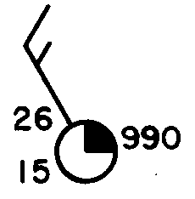
B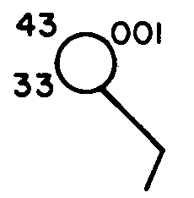
C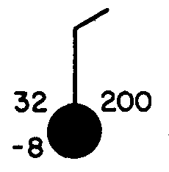
D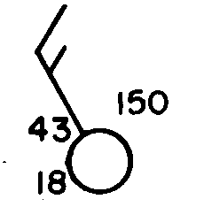
E