Name:_____________________ Period:___________________
Working With Contour Maps
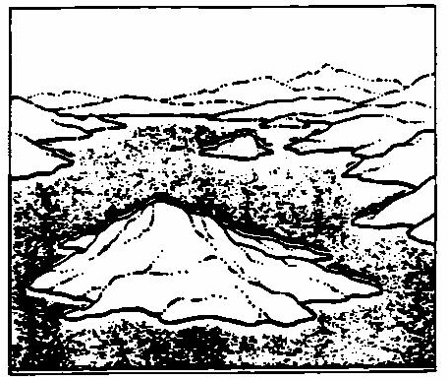
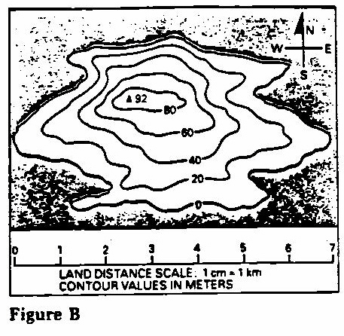

Figure A

Figure A shows an island. Figure B shows a contour map of this island.
Answer the questions below by studying the contour map.
1. a) How long is this island? _______________________
b) The long part runs _______________________ (north and south, east or west)
2. a) How wide is this island? _______________________
b) The wide part runs _______________________ (north and south, east or west)
3. This island starts at sea level. How do you know? (Look only at the contour map.)

4. What is the contour interval of this map? _______________________
5. a) Which side of the island has the steepest slope _______________________ (north, south, east, west)
b) How do you know which side of the island is steepest?

6. a) Which side of the island has the gentlest slope? _______________________ (north, south, east, west)
b) How do you know which side of the island is gentlest?

7. How high is the peak of this island? _______________________
8. Compare the drawing of the island with the contour map.
a) Which one gives more information? _______________________
b) Which one is more accurate? _______________________
c) Which one is more useful? _______________________
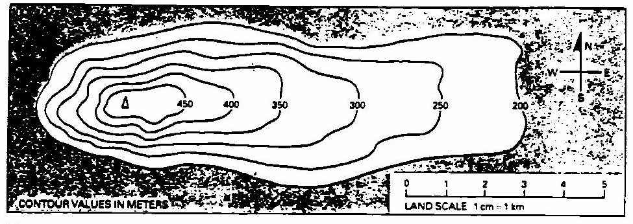
9. By compass direction…
a) the _______________________ side of this landform has the steepest slope.
b) the _______________________ side of this landform has the gentlest slope.
10. The contour interval of this map is _______________________ meters.
11. The lowest elevation shown is _______________________ meters.
12. Which of these heights could be the exact elevation of the peak?
a) 520 meters b) 420 meters c) 475 meters

You can learn more from a contour map than just the shape and slope of the land. Contour maps also tell you something about streams, “dips,” or depressions, in the land.
STREAMS
The head of a stream is the place where it starts. The place where it ends, in a lake or ocean, is called the mouth. Look at the figure below for the following questions.
13. What letter is at
a) the head of the stream? _______________________
b) the mouth of the stream? _______________________
14. Where contour lines “cross” a stream, they _______________________
15. a) Everyone knows that water flows _______________________ (uphill, downhill)
b) In other words, water flow from a _______________________ (higher, lower) elevation to a
_______________________ (higher, lower) elevation.
16. At a stream, contour lines seem to form “arrows.” Each “arrow” points…
a) toward the _______________________(head, mouth) of the stream.
b) _______________________ (upstream, downstream)
c) _______________________ (toward, away from) the direction of flow.
