LOST DOG
Red Golden Retriever
Female red collar blue leash
She needs epilepsy meds
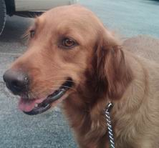
(631) 555-1212

